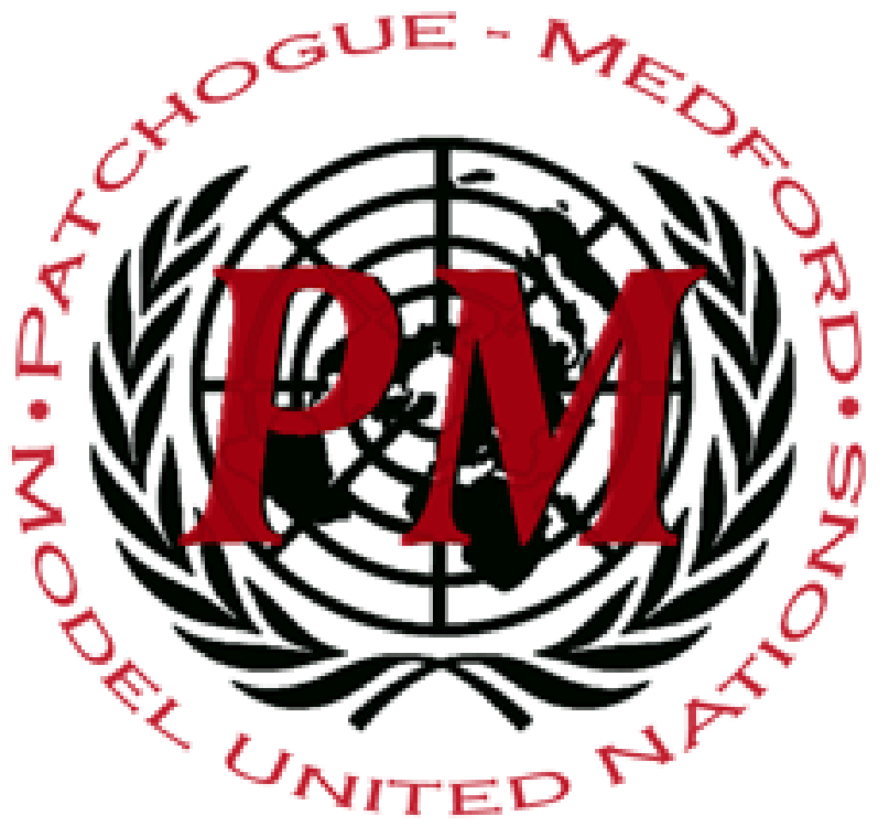
PatMedMUNCXII
European Union Parliament

Dear Distinguished Delegates,

Welcome to Patchogue Medford MUNC VII, and welcome to the European Parliament! We are your chairs, John Werner and Constantine Viennas. We are excited that you are going to be spending your Saturday with us, and cannot wait to see what new ideas and solutions you bring with you to the committee.
My name is John Werner, and I am a Junior at Patchogue Medford High School and thrilled to be your chair. This will be my second time chairing. I joined Model UN as a freshman, and it was easily one of the best decisions I have ever made. Model UN has done so much for me, opening me up to an array of fantastically smart and knowledgeable people from schools across the island and has allowed me to understand the world and see nations and peoples in new lights, an experience we are all truly lucky to have. At school, I throw shot-put and discus in Track, play bass clarinet in Pit Orchestra and the Wind Ensemble, and am the Co-Secretary General of Model United Nations. My goals for the future are to get accepted into the Huntsman Program at the University of Pennsylvania, work in investments and finance, and eventually become a US Senator.
My name is Constantine Viennas. I am a Junior here at Patchogue- Medford High School, this is my third year involved at our Model UN club, and this will be my first time chairing a MUN committee and I am beyond excited to be chairing! Outside of Model UN, I play street hockey at a competitive level. I also do swimming at an athletic level as well during the summer. I like to read and talk with friends during my free time, ranging from discussions about politics or domestic matters. In the near future, I hope to major specifically in International Relations or Political Science followed by a minor in Law in order to hopefully become a Diplomat or a Government Lawyer for the United States. If you ever happen to have a question about the modern Greek State, please ask me because I have a strange knowledge about those types of historical facts. Model UN, in my opinion is not only a club where a bunch of teenagers get together in a room to debate world issues but it is a gateway to the minds of the future, and also it’s a great place to meet new people because believe me, most of the people you are going to meet are really nice and are very open minded to you and your opinions. Take the time out their and meet some new people because they may not only be beneficial to your bloc in committee, but they may end up being your good friend. Also, please don’t be afraid to talk in committee, your voice matters and no one will ridicule you for speaking. On the other hand, good luck delegates!

Sincerely, Your chairs,

John Werner and Constantine Viennas

