PatMedMUNCXII
World Health Organization

Human Genome Editing

Human cloning is defined as the reproduction of a genetic copy of a human person. The three broad categories of cloning include Gene Cloning (or DNA cloning), therapeutic cloning and reproductive cloning. Gene cloning is the duplication of genes or segments of DNA. Therapeutic cloning is the production of embryonic stem cells to be used in medicine to repair or replace tissues, through somatic-cell nuclear transfer or pluripotent stem cell induction. Reproductive cloning refers to the reproduction of an entire human, rather than just tissues or cells.
For centuries, humans have had a rough knowledge of genetics, however, in the 1960s, when humans learned how to cleave and manipulate DNA sequences, the paradigm of the study of genetics shifted. Since then, high profile events such as the successful cloning of Dolly the sheep, and the embryonic cell transfer of the primates Nehi & Ditto, have popularized the idea of the potential of genetic manipulation and cloning. Impactful strides in genetic editing and cloning - specifically concerning humans - is now feasible. Characteristics such as the sex, eye color, and potential health conditions of an unborn fetus may soon be determinable and alterable with new bio-technology this has been labeled as “designer babies”, which further pushes the issue of ethical concerns faced by the choosing and discarding of certain traits going against the process of evolution.
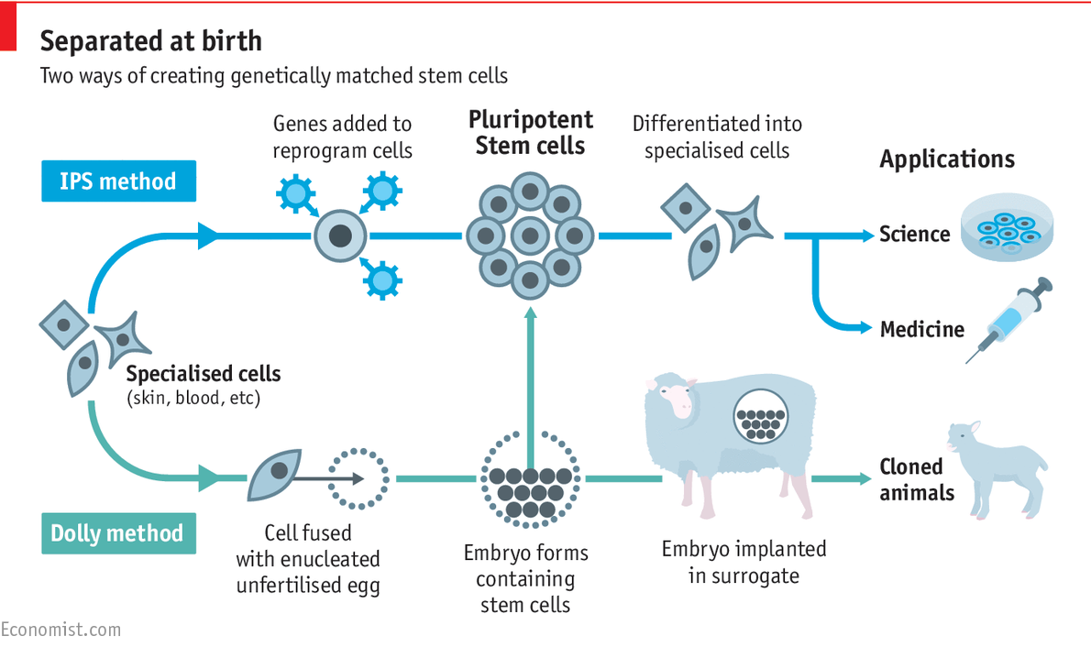
As these potentialities have begun to occur, several scientists, politicians, and certain informed citizens have begun to ask about what this new level of human potential must entail in terms of regulation and ethics. Many people and governments have agreed upon the use of gene editing in terms of removing certain diseases or issues such as down syndrome from the genes of unborn fetus’ but have also faced backlash from citizens of the public who look down upon the unnatural method of gene editing. Countries such as South Korea and China have fully embraced research into cloning human cells for both reproductive and therapeutic cloning, although China has been the most successful in their research so far.
The scientists who cloned Dolly the sheep have been able to successfully clone other sheep to produce milk containing a human protein needed for blood clotting, which in the future may be extracted to prevent blood clotting in patients which is necessary and can even be life saving in some cases. In addition, great promise has been shown in the research of stem cells which can be used for new medical treatments. Stem cells are the raw material in the body from which all other specialized cells are generated. Stem cells can be reprogrammed to replace damaged cells or tissue in the body that could help patients in many different nations but also brings about ethical issues in terms of practice and use of this research.
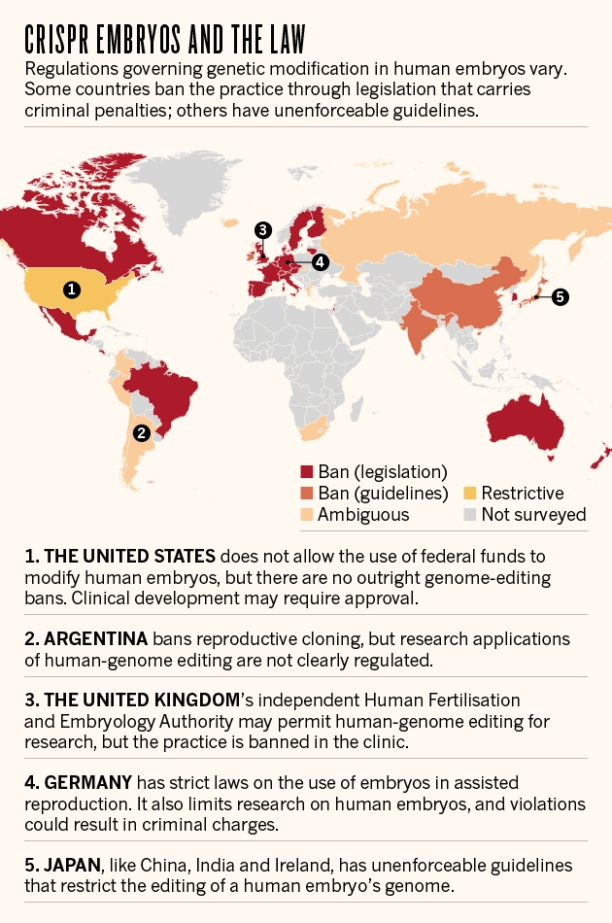
Religious groups have denounced human cloning and genetic manipulation and even some scientist groups have warned caution for fear of issues that may arise due to the unnatural nature of editing the human genome. Many countries have already passed or proposed their own legislation surrounding the ethics and practicality of performing the genetic experiments. Certain major topics of controversy include the use of animals for testing along with the potential use of such methods on human beings. It is up to you as a committee to come up with guidelines towards how human genome editing should be handled and if any restrictions should be placed to maintain ethics and morality.

Points to Consider:
- Has your country passed legislation to either fund or regulate genetic experimentation?
- Are there likely to be religious issues among your nations population regarding genetic experimentation?
- What are certain potential impacts that the future proliferation of genetic modification could have on class divisions?
- What are some legal ramifications that this issue might entail?
- How much involvement should the UN, as opposed to each individual sovereign nation, have in this issue?
Helpful Links:
https://www.genome.gov/about-genomics/policy-issues/what-is-Genome-Editing
https://www.yourgenome.org/facts/what-is-genome-editing
https://www.who.int/ethics/topics/human-genome-editing/en/
https://www.who.int/ethics/topics/human-genome-editing/GenomeEditing-FirstMeetingReport-FINAL.pdf?ua=1
https://www.mayoclinic.org/tests-procedures/bone-marrow-transplant/in-depth/stem-cells/art-20048117
https://medlineplus.gov/cloning.html
https://www.genome.gov/about-genomics/fact-sheets/Cloning-Fact-Sheet
http://www.animalresearch.info/en/medical-advances/timeline/cloning-dolly-the-sheep/

