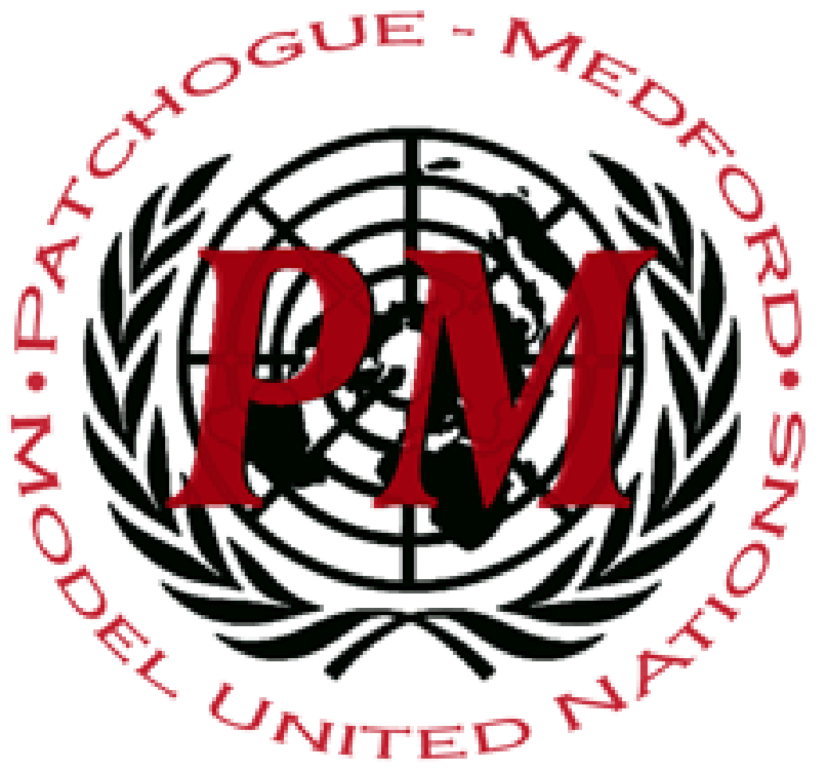
PatMedMUNCXII
Human Rights Council

Incidents of Hate Crimes

In many areas of the world, minority groups are targeted specifically because of their race, gender, gender expression, religion or sexuality. Such crimes with such specific targets and motives are referred to as hate crimes. Crime motivated by intolerance or discrimination of any kind is a broad concept, and that description is often used interchangeably with “hate crime” or “crime motivated by bias”. There is no global definition of the notion of crime motivated by intolerance and discrimination and in particular, no agreement on which characteristics of persons should be protected by specific legislation and policies. The scope of the protected characteristics varies over time and among countries. It may include race, religion, ethnicity, sexual identity, gender identity, gender and disability. To be considered a hate crime, the offense must meet two criteria: first, the act must constitute an offense under criminal law; second, the act must have been motivated by bias. Even in countries with many anti-discriminatory laws that make clear the consequences of such crimes, these minority groups are still attacked and oppressed.
Combating hate speech and hate crime is more urgent than ever. While no global reporting or monitoring currently exists, information collected by international and regional organizations, Member States and civil society organizations indicates worrying trends in crimes motivated by intolerance and discrimination all over the world. Gaps in available data and research persist, especially in Asia and Africa. In January 2019, United Nations Secretary-General António Guterres said the United Nations needed to engage societies to put an end to the rise of hate speech, xenophobia and intolerance, which posed direct threats to human rights, sustainable development and peace and security. At the end of April, the UN Secretary-General warned of a "disturbing groundswell of intolerance and hate-based violence" targeting houses of worship. In response, he set in motion two urgent initiatives: a UN plan of action to "fully mobilize" the system to tackle hate speech and an effort to help ensure the safety of religious sanctuaries.
Most countries have included general anti-discrimination provisions in their Constitution or their legislation. Some countries have also established specific legal provisions on hate crime motivated by intolerance or discrimination to varying degrees. Some countries are in the process of reforming their procedural criminal law to address crimes motivated by intolerance or discrimination. In European Union member States, challenges and gaps remain in relation to the racist and xenophobic motivations of crimes, the liability of legal persons and jurisdiction.
There have been legal developments in recent years regarding crimes committed against members of communities of lesbian, gay, bisexual, transgender, intersex and other persons. The repeal of discriminatory legislation is essential to enable victims to have access to justice without risking prosecution for engaging in same-sex relations. As an example, between 2011 and 2014, 14 States had adopted or strengthened anti-discrimination and hate crime laws, extending protection on grounds of sexual orientation and/or gender identity and, in two cases, also introducing legal protections for intersex persons. According to the International Lesbian, Gay, Bisexual, Trans and Intersex Association, in May 2017, 63 States had provisions that were either comprehensive or specific non-discrimination laws and 43 States had enacted laws under which a motivation of discrimination was considered an aggravating circumstance (including against lesbian, gay, bisexual, transgender, intersex and other persons).
Today, most countries have laws to address violence against women and some have criminalized gender-related killing of women. However, in many other countries, existing legal provisions are gender-neutral and do not allow for specific responses in cases of crimes motivated by intolerance or discrimination based on sex or gender. Moreover, not all forms of violence against women are criminalized or prohibited in many countries and some legal systems still retain provisions that discriminate against women or have a discriminatory impact on women, which allows perpetrators to escape criminal responsibility. Some countries have established the crime of femicide or feminicide in their criminal codes, although the subjective and objective elements of the crime vary. Other countries have included gender-related aggravating factors for homicide offenses or for offenses in general. It has been highlighted that including gender in domestic hate crime legislation, could help to prevent victim-blaming and promote offender accountability.
It is up to the Human Rights Council to prepare a resolution that seeks to prevent hate crimes, better investigate and bring justice to them, and create a method for implementing such actions into member states, among other things.
Points to Consider:
- What are the trends in your country relating to crime motivated by intolerance and discrimination?
- Do specific grounds for discrimination and intolerance or specific categories of crime require urgent priority action?
- Are additional standards necessary at the global or regional level?
- How should the national implementation of existing international and regional standards and commitments be promoted in UN member countries?
- What are the lessons learned from jurisdictions that have specific substantive and procedural criminal law provisions, for example on hate crime, gender-related killing, violence against women or violence against children?
- Can the inclusion of gender in hate crime legislation help enhance offender accountability while ensuring the safety and empowerment of victims of gender-based violence?
Helpful Links:
https://www.hrc.org
http://hatecrime.osce.org
https://www.unodc.org
https://www.legislationline.org/topics/topic/4
https://fra.europa.eu/en/theme/hate-crime

Works Cited:
European Union Agency for Fundamental Rights, Second European Union Minorities and Discrimination Survey: Being Black in the EU (Vienna, 2018).
https://www.hrc.org/blog/new-fbi-statistics-show-alarming-increase-in-number-of-reported-hate-crimes
European Union Agency for Fundamental Rights, Experiences and Perceptions of Antisemitism: Second Survey on Discrimination and Hate Crime against Jews in the EU (Vienna, 2018).

