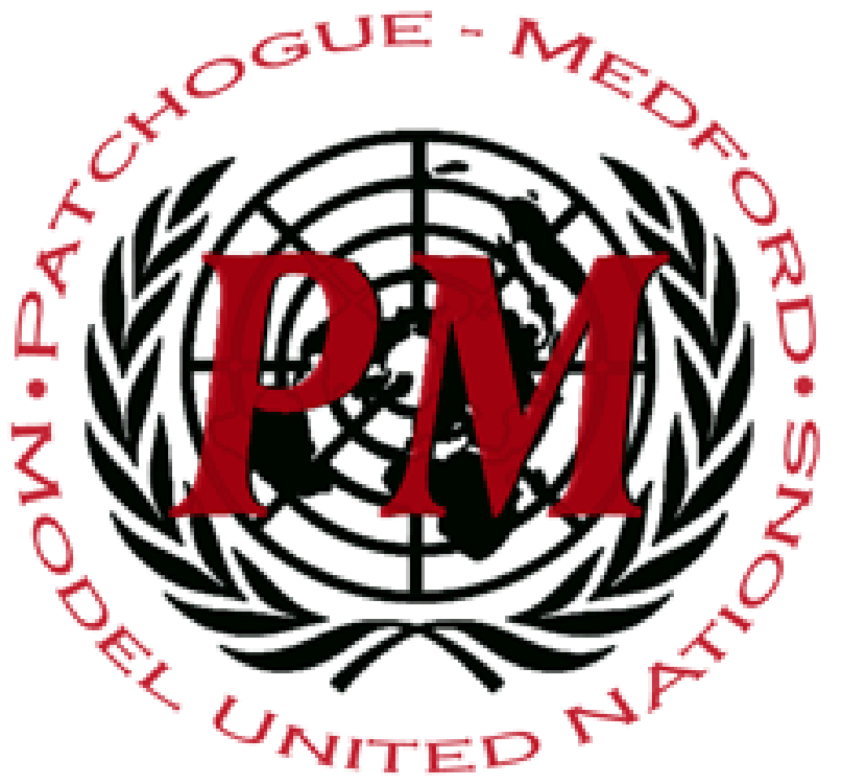
PatMedMUNCXII
UNESCO

Integration of Traditional Medicine and Modern Medicine

For centuries cultures looked to societal norms and personal experience to dictate their source of medicine and health care utilizing whatever was readily available to cure chronic pains and injuries as well as mental illnesses. Now as science progresses modern medicine begins expanding its practice and the world once dependent on homeopathic methods of treatment have the option to use more modern methods of healing. But there is still much to learn about modern medicine and due to human error bacteria has developed forms of resistance against antibiotics. Fortunately, traditional medicine can solve this crisis because the medicine is naturally occurring and has been around for centuries and the side effects are well known. Therefore the need for integration and coagulation of these two branches becomes more important as medicine progresses.
For some developing countries access to western medicine is very minimal, therefore traditional medicine continues to be the main source of health care. “There are strong indications that traditional health care systems are still in use by the majority of the people not only in Africa but across the world”(Express Healthcare). Therefore the problem when it comes to providing the best form of health care is not how much traditional medicine but rather the balance between modern and traditional. It is also possible that achieving the perfect balance between using traditional and modern medicine has more to do with a country's development and the availability of western medicine as Africa is predominantly filled with developing countries who are not able to supply the medicine and qualified professionals necessary to practice modern medicine. Therefore it becomes a concern for these countries that the availability of more modern medicine is improved rather than in a more developed nation which has the proper balance of modern medicine but needs to look toward more homeopathic and traditional forms of medicine instead of just prescribing medicine.
The most important aspect for consideration is that the success of this integration and its impact on the lives which are at stake if modern medicine doesn’t blend with the traditional. “…European researchers estimate that more than 33,000 people in Europe die each year from antibiotic-resistant infections and that the growing health burden of these infections is similar to that of influenza, tuberculosis, and HIV combined” (Dall). To mitigate the loss of life from antibiotic-resistant bacteria requires cooperation on the global platform to ensure that the medicine put in place of heavier antibiotics are clean and up to code for human consumption. As well as a development in understanding when it comes to the new medicine being generated as well as consumer education of the harmful impacts of defying a regiment set up by their health care provider.

Points to Consider
- Does your country depend mostly on traditional or modern medicine?
- Does your country already have a system in place for using traditional and modern medicine together?
- What is your country’s history in regards to medicine used for illnesses?
Helpful links:
https://www.ncbi.nlm.nih.gov/pmc/articles/PMC6273146/
https://www.scidev.net/global/indigenous/feature/integrating-modern-and-traditional-medicine-facts-and-figures.html

Work Cited:
Dall, Chris. “European Study: 33,000 Deaths a Year from Resistant Infections.” CIDRAP, 6 Nov. 2018, www.cidrap.umn.edu/news-perspective/2018/11/european-study-33000-deaths-year-resistant-infections.
“Integrating Traditional and Modern Medicine.” Express Healthcare, 16 Apr. 2019, www.expresshealthcare.in/blogs/guest-blogs-healthcare/integrating-traditional-and-modern-medicine/410987/.

