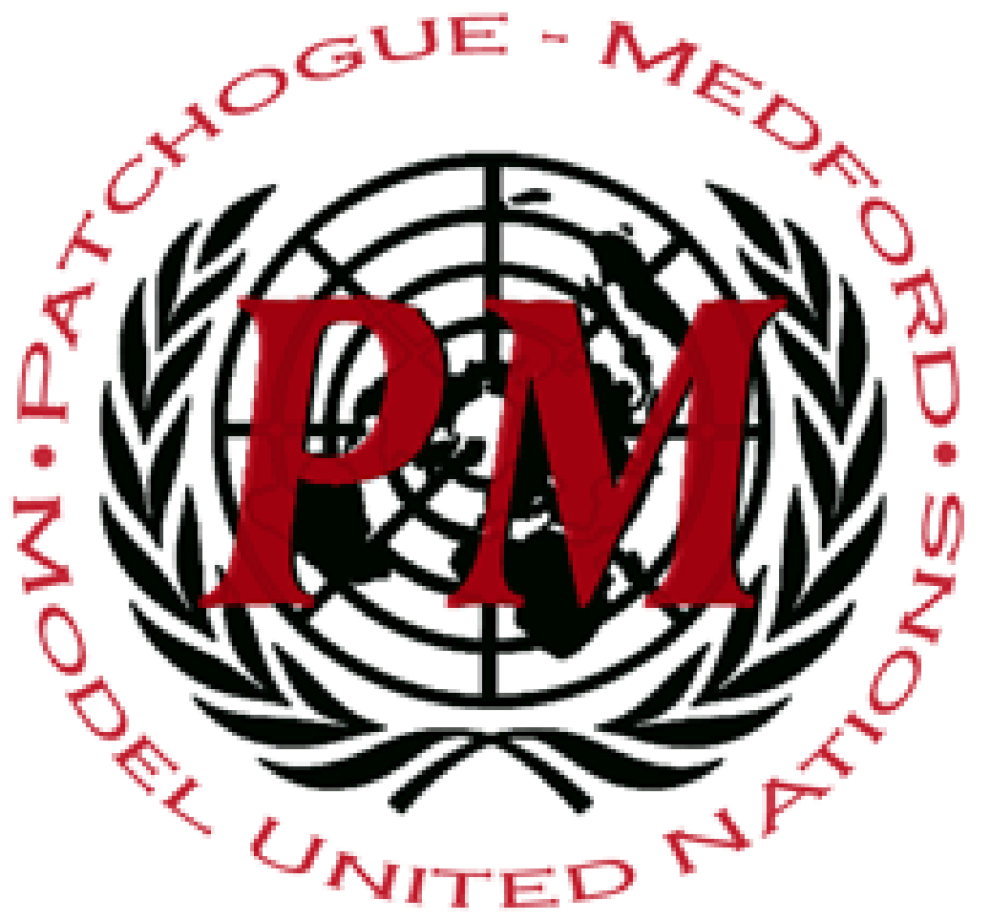
PatMedMUNCXII
Security Council

Militarization of the Arctic and Antarctic

As the effects of climate change become more drastic and technology improves the areas of the planet once considered uninhabitable; hot spots for resources, defense, and commercialization has lead to conflict in parts of the Arctic and Antarctic. As the Arctic ice sheets melt, land is revealing under ice sheets, many valuable natural resources exist such as large deposits of metals, over 90 billion barrels of oil, and 47 trillion cubic meters of natural gas. These resources total over $22 trillion USD and many countries are trying to stake their claim.
Many countries in the north are militarizing northernmost borders of their nations looking to protect this newly acquired land. Russia has gone to the UN to make a claim of 1.2 trillion square kilometers.They claim that their continental shelf extends further into the region and should be considered Russia’s Exclusive Economic Zone(EEZ). An EEZ is defined as territory 200 nautical miles offshore that a nation is allowed to enact non-discriminant laws and controls commercial in this area. Other northern nations have decided to increase defense in this area. The new open Arctic provides easier passage through the region for commerce and defense. Nations such as Canada, the Netherlands, Denmark, Norway, and the United States have increased spending on defense of this area. The United States is moving military to Alaska while training troops to fight in harsh winter conditions. Even nations not considered northern nations are trying to join the stage. China, which has many icebreaker ships and has declared itself apart of the conflict. Russia has the most icebreakers, around 40, followed by Canada with 20 and Finland with 12. Other nations are scrambling to produce their own ships and arctic outposts to lay claim, maintain peace, keep the area an international zone, or defend their land.
The Antarctic is a similar situation, however with less conflicts, as the land is still deep under ice. Although the archipelago is far from being revealed, this land has potential to be a highly conflicted territory as it contains many untapped natural resources, such as iron nickel and rare earth metals. With most of the territory claimed by several nations such as France, the United Kingdom and Norway, some still remains unclaimed. With large oil deposits located under, the soon to be revealed land, the land is potentially an economic and strategic area for future exploration, commercialization, and conflict.

Points to Consider:
- What does your country want to do in the Arctic Zones?
- How does this new land affect your nation?
- What has your nation done and/or are doing in the Arctic Zones?
Helpful Links:
https://www.strategic-culture.org/news/2018/10/24/militarization-arctic-issue-incredible-importance-not-given-due-attention-to/
https://discoveringantarctica.org.uk/challenges/sustainability/mineral-resources/

