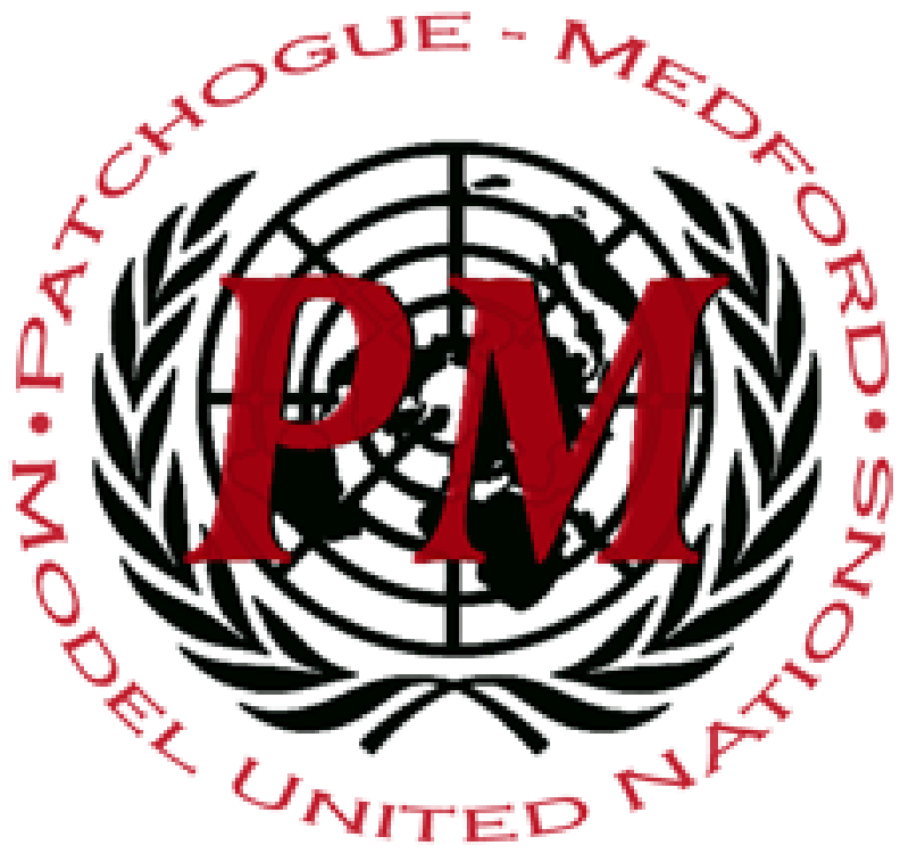
PatMedMUNCXII
Human Rights Council

Protecting Freedoms to
Assemble and Protest

Every nation has a different perspective on how much sovereignty their civilians are alloted. In regards to freedoms to protests and assemblies, there are democratic nations that believe in the protection of said actions as long as they are done peacefully and is for the betterment of human rights in a community. Meanwhile, some nations condemn the idea of peaceful protests, as they believe their power is being questioned and condemned. Protesting allows for a group of people to criticize what is going on in a nation or demand change.. The United Nations has long recognized that peaceful protest is an essential human right, as the right to peacefully protest as outlined and protected in the Universal Declaration of Human Rights in 1948. The problem that persists is that this right is overlooked by many nations, and there is still a gray area in what is allowed and condemned in expressing one’s rights.
Globally, there are many countries that ignore this right for individuals to peacefully protest. Recently in Hong Kong, protests have been met with a high demand of force by the local police. These protests were a result of a new Extradition Bill that was passed. This bill allows for mutual legal assistance to be made between Hong Kong and any other nation. This makes civilians fear about their government and how their markets will be impacted. Instead of letting the civilians have a say in this affair, the government has been combatting this expression of freedom. The government does not want their authority and legitimacy questioned. There have been approximately 2000 injuries and 750 arrests. There have also been threats of military involvement by the Chinese military, as these protests are being treated as terrorist events.
In Russia, there has also been a series of suppressed protests. In the last few months, specifically from April to the present time, there have been protests among the Russian civilians in Moscow. These protests were a result of people believing there was a flaw in their local elections. Russians felt that the recent actions by government officials allowed for more people of their party have power. Outside Moscow City Hall, protestors were met with strong confrontation by the police, as they were detained.. One of the opposing candidates was said to be detained by just feeding some of the protestors. It has been recorded that over one thousand people have been detained. The Human Rights Committee, the United States, and the European Union have condemned this brutality on civilian life, but it has not made an impact.
While some nations ignore the rights of global citizens to practice peaceful protests and assemblies, others do not. Nations like the United States of America have embraced the idea of peaceful protests. In 2018, the Women’s March in New York City was a planned and effective event. Anyone that supported expanding the rights of women were invited to express their ideas. There were about one and a half million protestors. Instead of police fighting off the participants, they instead closed down roads and made sure the American civilians were safe in expressing their rights. There have also been a plethora of other types of protests; Rights for the LGBTQ+ community, the March for Our Lives, the March for Science, and many more. These enable human beings to express themselves and stand up for what they believe in, which is a fundamental value in the Human Rights Committee.
Global protestors have also been blamed for some of their actions. Earlier this year, Albanian civilians became outraged as they believed the country was facing election fraud, and the blame was placed on the Prime Minister. This outrage resulted in violent protests, as petrol bombs were thrown at the Prime Minister’s office. There were also a variety of weapons used against police, causing the police to respond with tear gas and the protests violently escalating.
As observed in recent years, there are multiple problems at hand when considering this topic. Governments are abusing their power over the civilian’s right to speak up and protest. However, there needs to be a stronger guideline in place to ensure the safety of all living beings across the world. It is your duty, as a delegate of the Human Rights Committee, to resolve the issue.

Points to Consider:
- What is your nation’s government stance on peaceful protests?
- How has your government responded to civilians protesting or forming assemblies?
- How did your nation react to the Universal Declaration of Human Rights?
- What protests have occurred in your country?
- Has your nation been an important role in protests and assemblies in another country?

Helpful Links:
https://www.cia.gov/library/publications/the-world-factbook/
https://www.ohchr.org/EN/HRBodies/CCPR/Pages/CCPRIndex.aspx
-changing-the-world-now/
https://www.un.org/en/universal-declaration-human-rights/
https://www.globalcitizen.org/en/content/peace-protests-dallas-response/https://www.globalcitizen.org/en/content/8-protests

