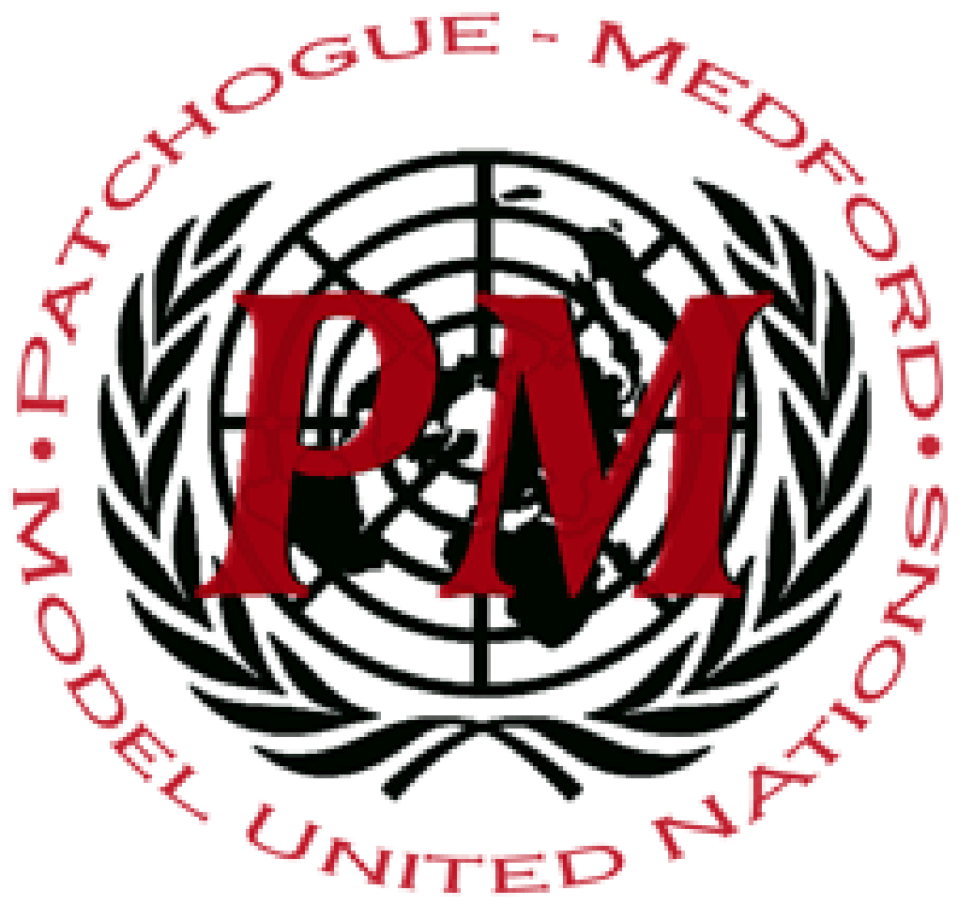
PatMedMUNCXII
Human Rights Council

The Preservation of Human Rights for IDPs and Refugees

The threatened rights of IDPs and refugees pose a great international threat. The difference between the two is often unclear. An IDP, or an internally displaced person, can be defined as someone who is forced to flee his or her home but who remains within his or her country's borders. A refugee, however, is someone who is forced to flee not only their home, but their country in order to escape threats of persecution, war, or natural disasters. According to the OHCHR, the overwhelming majority of internally displaced persons are women and children who are especially at risk of abuse of their basic rights. More often than refugees, the internally displaced tend to remain close to or become trapped in zones of conflict, caught in the cross-fire and at risk of being used as pawns, targets or human shields. The Guiding Principles on Internal Displacement, created in 1998, restate the existing international human rights that should be given to IDPs and refugees. They state that these people fleeing for their lives still maintain a broad range of economic, political, civil, and social rights. However, refugees and IDPs are not able to exercise these supposedly given rights, calling for a better system to ensure international human rights are being safeguarded.
In 2014, Pakistani troops went into North Waziristan Agency of the Federally Administered Tribal Areas, and many families were forced from their homes. These families were forced to new places to reside, and the Pakistani government failed to protect these internationally displaced individuals. The FDMA has stated that 87,778 families from this area became displaced. The Pakistani government originally only assisted IDPs ith 5 million dollars, and there was a lack of strategy in distributing aid to IDPs. As illustrated, this was a pressing issue that was never resolved. The lack of care that government's take in displays;aced peoples is problematic in protecting the human rights that are outlined in the Declaration of Human Rights.
One instance where this problem is prominent is Australia. Approximately 1200 asylum seekers were forcibly transferred to a remote island of Nauru, which is an island northeast of Australia. At this remote location, civilians are facing severe abuse and neglect to medical treatment, sufficient resources, and other items that are essential to individuals living healthy lives. The Human Rights Watch has recognized this as a problem, and Australia has had multiple opportunities to speak on behalf of all accusations in the Human Rights Committee. However, there has not been any sufficient change.
At a global level, no organization has been delegated the task of leading the protection and assistance of internally displaced persons. Rather, all are called upon to cooperate with each other to help address these needs pursuant to the "collaborative approach". It is up to the Human Rights Council to determine how best to safeguard the rights of those in need of protection.
Points to Consider:
- Is the displacement of people a prominent issue in your country?
- Has your country opened its doors for refugees?
- If so, how has your country safeguarded their rights (or threatened them)?
- What international programs has your country taken part in to aid refugees and IDPs?

Helpful Links:
unocha.org/es/themes/internal-displacement
https://adra.org/beyond-the-crisis-global-refugee-facts/
https://www.crisisgroup.org/asia/south-asia/pakistan/pakistan-worsening-idp-crisis
https://www.hrw.org/news/2019/01/17/australia-reverse-cruel-refugee-policy

