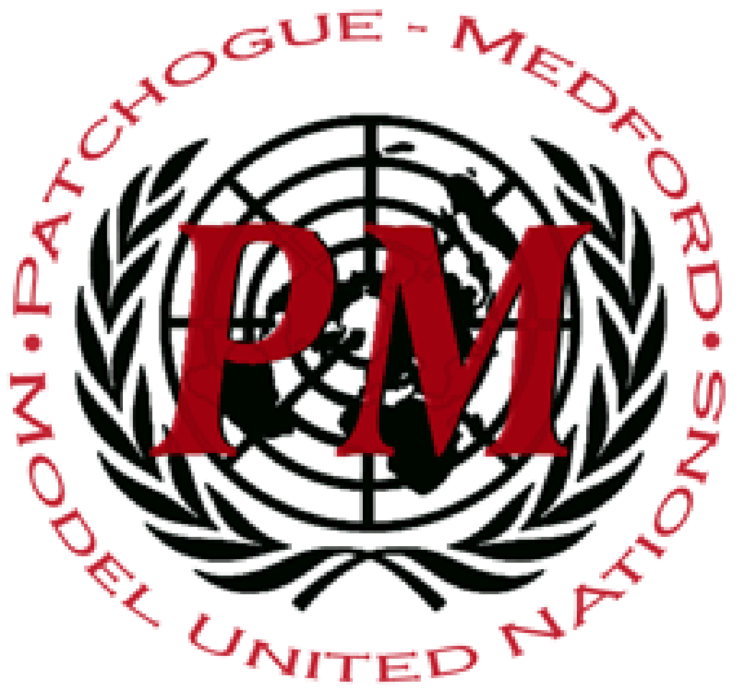
Office for Outer Space Affairs (OOSA)
Dear Delegates,

Welcome to the Patchogue-Medford MUNC XII’s United Nations Office of Outer Space Affairs, otherwise known as UNOOSA! UNOOSA was founded over 60 years ago in 1958, as an effort to continue peaceful international relations into the cosmos. UNOOSA has worked alongside the United Nations General Assembly to implement and uphold all space-related resolutions, some of which you will be discussing with your fellow delegates. The issues that will be discussed in committee are: Privatization of Space Travel, Militarization of Space, and Space Waste Management. As a committee you and your fellow delegates will work to find common ground on these pressing issues before any impending dangers may occur.
Hi! I’m P.J. Osheske (also known as famous YouTuber “YoItsPJO”), and I’m a senior here at Pat-Med. This my second year chairing, and I’m so excited to be chairing UNOOSA. Outside of MUN, I am the senior class president, I write movie reviews for the school newspaper, and I am currently performing protein crystallization/modeling research at the NSLS-II at Brookhaven National Labs. I’m sad that this is my last year at Pat-Med MUNC, but I’m really excited to get to end my career with such an epic committee. Good luck delegates!
Hey, my name is Maha Nayyer. I am a senior here at Patchogue Medford HS. I have been in Model United Nations for three years now and it is my first year charing. I cannot wait to chair UNOOSA and make it the best committee! In addition to Model UN, I am the president of French HS, Secretary of Corporate Raiders, and a member of several extracurricular activities. I look forward to college next year as I want to major in Law and minor in Art. I look forward to meeting everyone and having a great debate! Enjoy:)

Sincerely,

P.J. Osheske Maha Nayyer

