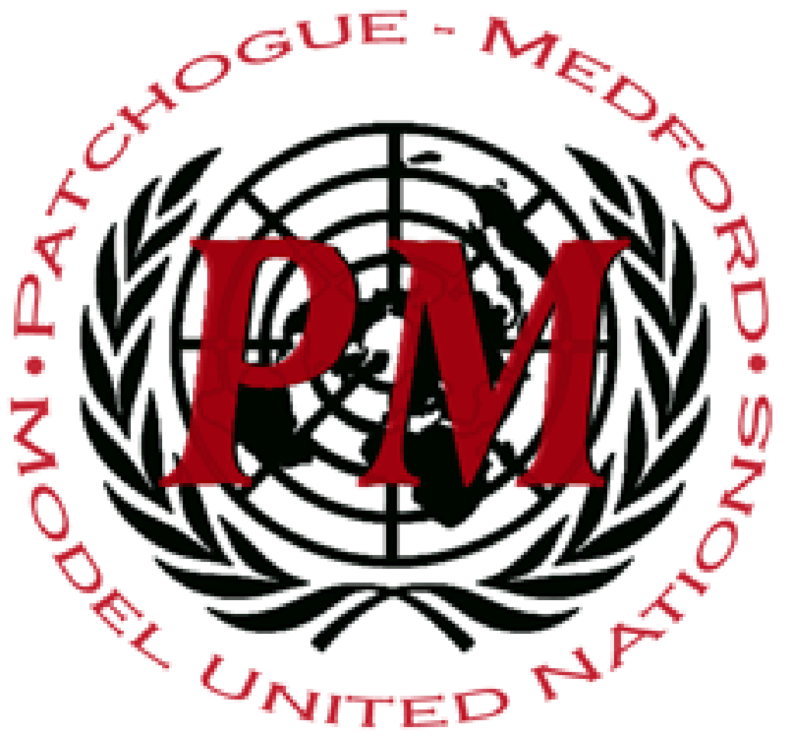
PatMedMUNCXII
World Health Organization

Vaccinations

As defined by the World Health Organization, vaccines are a form of “biological preparation that improves immunity to a particular disease”. Vaccines are used globally to prevent, treat, and eradicate dangerous diseases. However, due to accessibility issues in providing vaccines and a spread of harmful misinformation across social media platforms, vaccine hesitancy was named by the WHO to be one of the top ten threats to global health this year. The decrease of vaccinations is causing the return of diseases such as polio, measles, and tetanus; all of which can be fatal if left untreated.
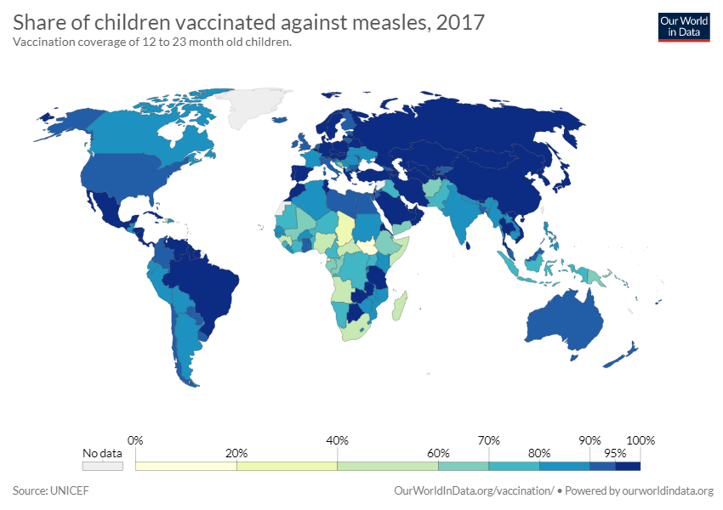
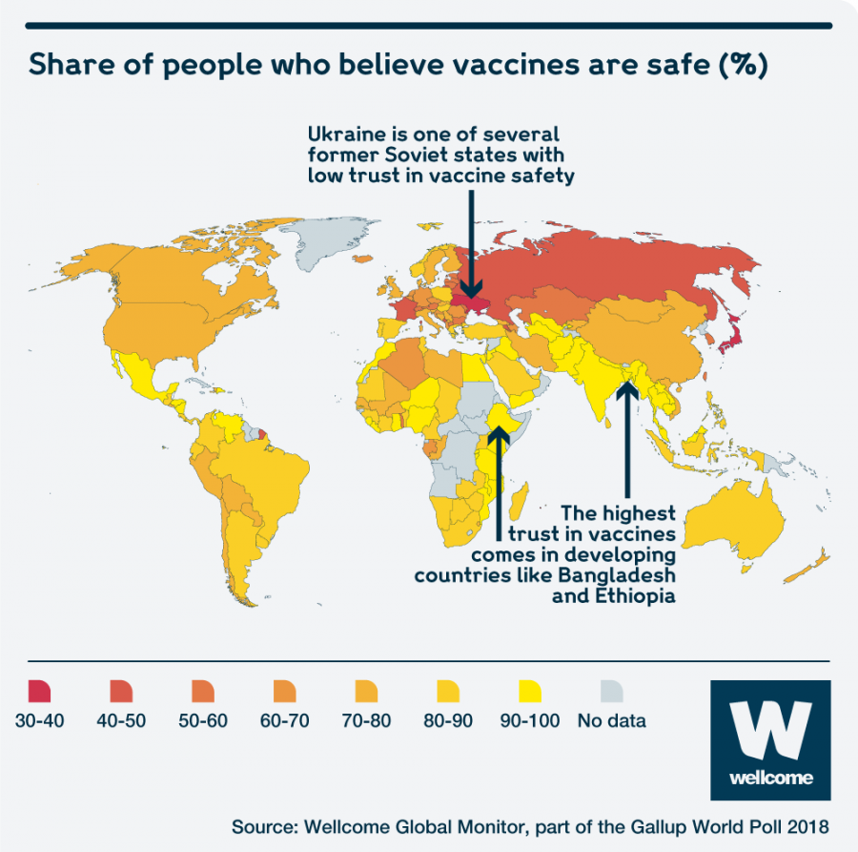
Vaccine accessibility is essential in all countries, especially those facing political instability. Many war-torn countries are unable to provide vaccines for their citizens, resulting in countries such as Pakistan, Afghanistan, and Nigeria being places with a larger polio problem than others. Similarly, countries including India, Brazil, and the Democratic Republic of the Congo were some with the highest number of unvaccinated infants as of 2018. To combat this, the World Health Organization has taken many steps both on the international level and within specific countries. For example, in May 2012 194 member states of the World Health Organization came together to form the Global Vaccine Action Plan, referred to as GVAP. GVAP was a plan that sought to lower fatalities worldwide by creating new infrastructure that would provide already existing vaccines to underdeveloped communities. Despite the large support for GVAP, plans are already behind schedule and over-budget, pushing back the original end set at 2020.
On the other hand, in more developed regions of the world, a very different threat is facing the World Health Organization from providing vaccinations to all citizens: misinformation. On social media websites, there are many groups of individuals dedicated to spreading misinformation about vaccines, making false and unbacked scientific claims about the effects of vaccines on humans. There have been many reports made of Russian and Iranian “bot” accounts being used to post factually incorrect information about vaccinations, feeding into this false fear of vaccines. This has caused many groups and communities of anti-vaccination citizens, or “anti-vaxxers”, to form, causing the return of previously preventable diseases. For example, the United States has seen a rise in measles, a disease declared eradicated in 2000, due to international travelers and anti-vaccination beliefs.
The debate on vaccine accessibility and the anti-vaccination movement is one that needs to be solved swiftly, as many lives of all citizens of the world are at stake. When discussing a resolution as a committee, keep in mind the national sovereignty of each nation while also working towards a compromise that will benefit the global community as a whole in the greatest way.

Points to Consider:
- Does your country have highly accessible vaccines? If not, in what areas are vaccines not accessible?
- Are there any restrictions on social media sites in your country to aide in stopping the spread of misinformation? If so, are they successful?
- In what ways has your country attempted to vaccinate more citizens and how effective are these methods?

Helpful Links:
https://www.who.int/immunization/global_vaccine_action_plan/GVAP_doc_2011_2020/en/
https://www.who.int/news-room/fact-sheets/detail/immunization-coverage
https://www.who.int/immunization/research/en/
https://measlesrubellainitiative.org/anti-vaccination-movement/
https://www.who.int/publications/10-year-review/vaccines/en/
https://www.who.int/immunization/en/
https://www.vaccines.gov/who_and_when

