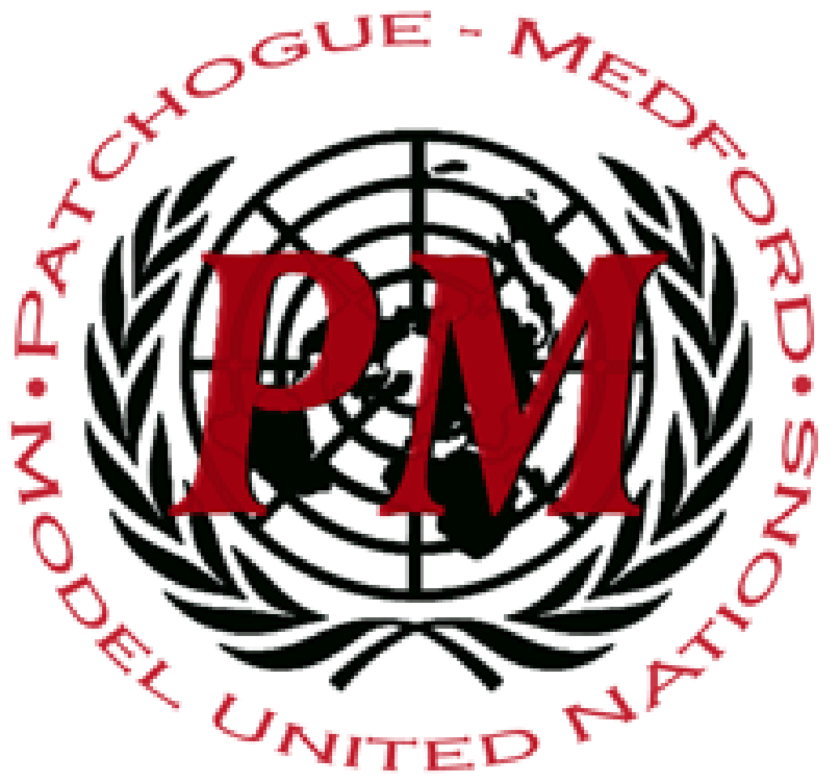
Pat-Med MUNC XI
World Health Organization (WHO)

Dear Distinguished Delegates,
Welcome to the World Health Organization at Patchogue-Medford MUNC XI! The World Health Organization , better known as WHO, is a specialized agency of the United Nations. The committee was created in 1948 for the purpose of creating resolutions to solve issues of international public health. The main concerns of this committee is to create safer living conditions worldwide through the creation of protocols and programs to solve ongoing global conflicts. This weekend we are looking forward to working towards solutions and compromises on hot-topic issues as a committee. This weekend we will be discussing mental health, vaccines, and human genome editing. To ensure that this experience will be as enjoyable as possible for all, we would like to remind all delegates to act in a professional manner and to follow parliamentary procedure during committee.
Hi delegates! My name is Sarah Emr and I’m also one of your chairs at the upcoming Conference. I’m a senior here at my school and have been in Model U.N. for 4 years. You may know me from past conferences or helping run the conferences at my school as treasurer and crisis consultant. Outside of Model U.N., I’m my Class President, G.O. President, Ex-Officio Student Member of the Board of Education, Treasurer of French Honor Society and a member of four other honor societies. I am also on the academic team and Girls Inc. At my school, I am heavily involved with virtual enterprise and plan to be the CEO of the company. In addition, I’ve attended the HOBY Leadership Seminar, Theodore Roosevelt’s Summer Honors Institute, EDNY Justice Institute, and Girls State. Less boringly, I love Mac and Cheese, rock at board games, enjoy jamming to music, and love movies. I hope you enjoy committee and I can’t wait to meet everyone. Good luck!
Hi I am Jeffery, I like long walks on the beach and Model UN is pretty cool in my opinion. Thanks love you guys!
We hope every delegate enjoys their time within the committee and is able to speak and further move the discussion. Hopefully everyone stays respectful and follows all MUN procedures throughout the conference. Foremost however, everyone will hopefully have fun discussing the exciting topics in store for them. Perhaps even have some of our resolutions help the actual World Health Organization. We can't wait to meet everyone and enjoy an amazing conference.

Sincerely,
Sarah Emr and Jeffery Tejada

