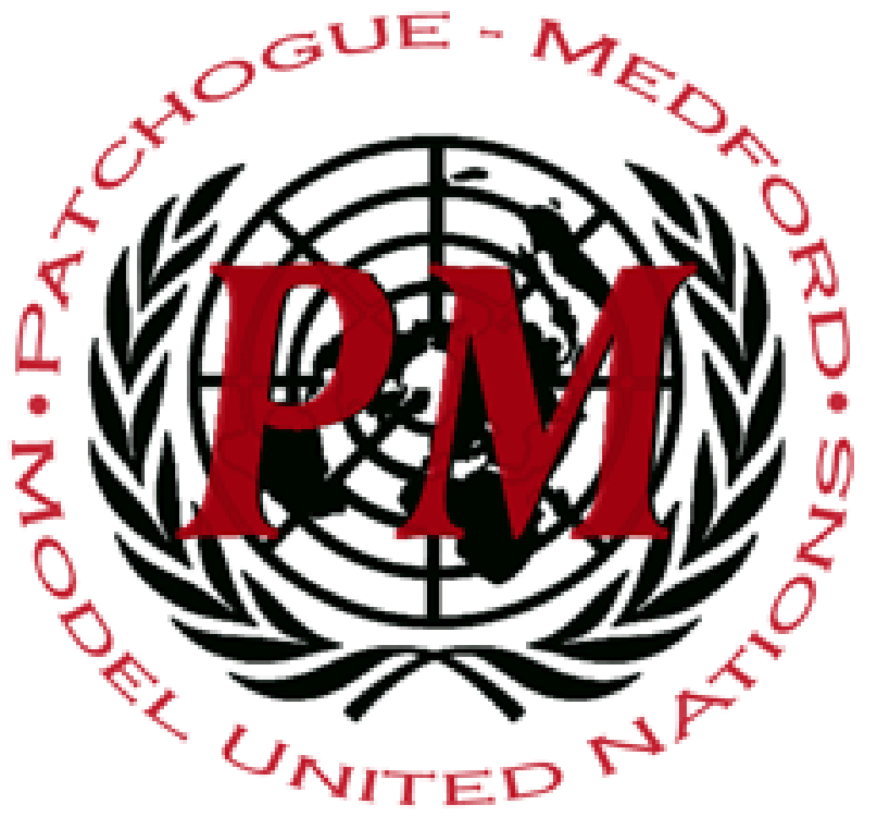
Pat-Med MUNC XI
World Health Organization (WHO)

Dear Distinguished Delegates,
Welcome to the World Health Organization at Patchogue-Medford MUNC XI! The World Health Organization , better known as WHO, is a specialized agency of the United Nations. The committee was created in 1948 for the purpose of creating resolutions to solve issues of international public health. The main concerns of this committee is to create safer living conditions worldwide through the creation of protocols and programs to solve ongoing global conflicts. This weekend we are looking forward to working towards solutions and compromises on hot-topic issues as a committee. This weekend we will be discussing mental health, vaccines, and human genome editing. To ensure that this experience will be as enjoyable as possible for all, we would like to remind all delegates to act in a professional manner and to follow parliamentary procedure during committee.
Hello, I’m Ethan Phan and I’m one of your chairs for today’s conference and I would like to welcome you to Patchogue - Medford High School Model United Nations Conference. I’m a Junior and interested in Computer Science which is what I hope to continue studying over the next few years. A little fact about me is I’m fluent in Vietnamese. I also play Badminton and I’m on the schools Math team. This is my first time chairing, all I hope is that you all have fun and enjoy your time here as it’ll make my first year chairing as fun as it could be.
Hello delegates, I would like to welcome you all to WHO. I am your second chair, Genesis Guevara. I am an alumnus of Patchogue-Medford High School and have decided to come back and chair for my fourth year in a row. This is my second time chairing WHO and I am so excited to see what kind of debate is brought to the table this weekend. I am currently a freshman at Suffolk County Community College majoring in Political Science and am planning on transferring to Stony Brook next year to study abroad in South Korea. I am aiming towards becoming a lawyer specializing in international affairs which was introduced to me through my love for Model UN.
We hope every delegate enjoys their time within the committee and is able to speak and further move the discussion. Hopefully everyone stays respectful and follows all MUN procedures throughout the conference. Foremost however, everyone will hopefully have fun discussing the exciting topics in store for them. Perhaps even have some of our resolutions help the actual World Health Organization. We can't wait to meet everyone and enjoy an amazing conference.

Sincerely,
Genesis Guevara & Ethan Phan

